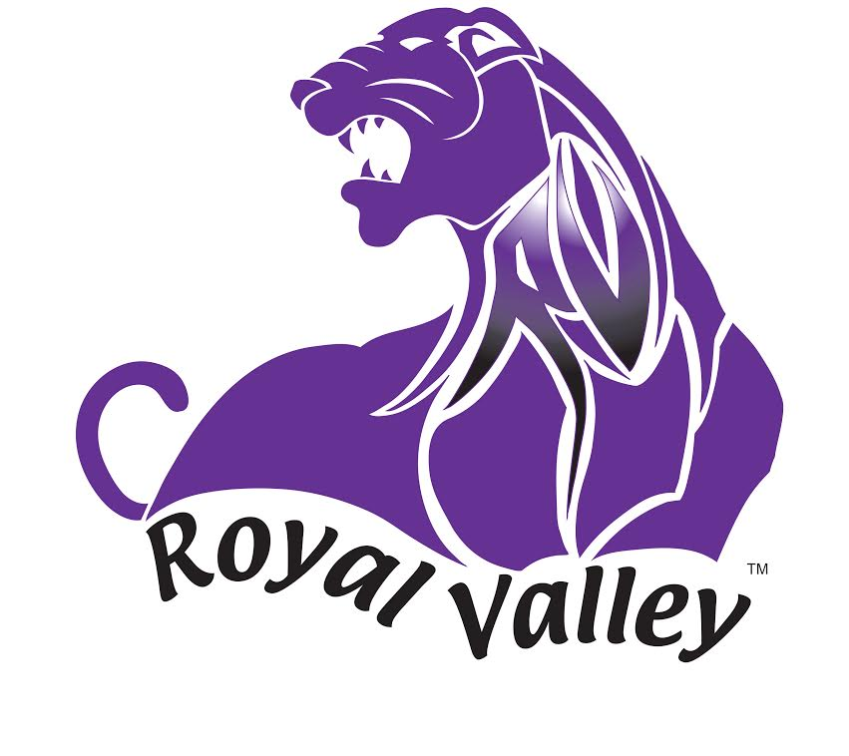

Coaches;

I want to welcome you all to the 2021 Royal Valley Cross Country Invitational.

Please be sure to enter the park through the south entrance. If you need directions to the park please call me at your convenience.

If you are using Map Quest or GPS, you may use the following address to get a map to the Hoyt City Park; 699 Highland, Hoyt, KS 66440

Other information about the meet is on the pages that follow.

ROYAL VALLEY CROSS COUNTRY INVITATIONAL
THURSDAY SEPTEMBER 23, 2021
TO: Principals, Athletic Directors and Cross Country Coaches
FROM: David Schooler, TELEPHONE 1-785-986-6251
RE: Royal Valley Cross Country Meet on September 23, 2021

LOCATION: The meet will be held at the Hoyt City Park. Please enter
the park from the south entrance. You may refer to the map enclosed.

ENTRY FEE: HS Girls- $10 per runner or Team maximum of $50
HS Boys- $10 per runner or Team maximum of $50

MS Girls- $8 per runner or school maximum of $50
MS Boys- $8 per runner or school maximum of $50

SCORING: We are planning on using a FinishLynx camera system for our finish line.

SCHEDULE: 4:00 7th Middle School Boys & Girls (2 mile)
4:30 8th Middle School Boys & Girls (2-mile)
5:00 JV Boys
5:45 Varsity/JV Girls
6:30 Varsity Boys
We may run ahead of schedule if possible depending on entries in the races.

You may enter as many Junior Varsity boys and girls as you want.

SCHOOLS: The following schools have been invited to attend:
Holton HS/MS, Jackson Heights HS/MS, Jeff West HS/MS, McLouth HS/MS, Perry-Lecompton HS, Rossville Sr./Jr. HS, Santa Fe Trail HS/MS, St. Marys HS/MS, Atchison MS, Seaman MS, and Silver Lake Jr./Sr. HS, Wamego HS (JV).

ENTRIES: Please submit entries via Athletic.net using the following instructions by 9:00 am Sep. 21st.

There will be an awards ceremony. We will pass out middle school awards during the boys JV race so that middle school teams can leave if necessary.
AWARDS: Boys Varsity 20 Medals
Girls’ Varsity 20 Medals
Boys JV 10 Medals
Girls JV 10 Medals
MS Girls 7th 10 Medals
MS Boys 7th 10 Medals
MS Girls 8th 10 Medals
MS Boys 8th 10 Medals
Boys and Girls trophies will be awarded to the top two Varsity teams.

ROYAL VALLEY CROSS COUNTRY INVITATIONAL
THURSDAY SEPTEMBER 24, 2020

Please submit entries via Athletic.net by Tuesday –September 21, 2021 by 9:00am.

School: __________________________

NUMBER OF HIGH SCHOOL RUNNERS: ($8 per Individual or $40 per team)

Girls - $8.00 per runner or Team max $40.00 $40.00_______

Boys - $8.00 per runner or Team max $40.00 $40.00_______

Total- $80.00_________

NUMBER OF MIDDLE SCHOOL RUNNERS: ($5 per Individual or school max of $80.00)

Girls - $5.00 per runner $_______

Boys - $5.00 per runner $_______

Total- $_________

Please mail your check to RVHS ASAP.

We are looking forward to an excellent meet. If you have any questions,
please call David Schooler at 785-986-6251 or email to schoolerd@rv337.org

Coaches email Address:________ ____________________________________

ROYAL VALLEY CROSS COUNTRY INVITATIONAL
THURSDAY SEPTEMBER 23, 2021

